Computer Architecture Lab
(EL-2012)
LABORATORY REPORT

Fall 2026

(Lab#2)
Implementation of Combinational Circuits using Verilog Gates & DataFlow Level Modeling

Student Name: Syed Muhammad Shuja Abbas Naqvi Roll No: 24I-6539 Section: A

Date performed: 4th September, 2026

MARKS AWARDED: ________ / 10

Signature and date of Instructor: _________________
Lab Instructors: Dr. Nasir Ali Shah, Engr. Fasih Ahmad

______________________________________________________________________________________________________________________________________________________

NATIONAL UNIVERSITY OF COMPUTER AND EMERGING SCIENCES, ISLAMABAD
Prepared by: | Fasih Ahmad |  | Version: 1.0
Verified by: | Dr. Nasir Ali Shah |  | Updated: Fall 2026

Task 1:

Description:
In this task we Wrote Verilog Code for Half Adder and Full adder using Gate level and Dataflow level modeling. Simulated it by writing testbench and then made the circuit in logism.
Code:
GATE
module halfadder(sum,carry,inputA,inputB);
input inputA,inputB;
output sum,carry;
xor(sum,inputA,inputB);
and(carry,inputA,inputB);
endmodule

module fulladder(SUM,cout,inputA,inputB,Cin);
input inputA,inputB,Cin;
output SUM,cout;

wire sum1,c1,c2;
halfadder h1(sum1,c1,inputA,inputB);
halfadder h2(SUM,c2,sum1,Cin);
or(cout,c1,c2);
endmodule

module testbench;

reg inputA,inputB,Cin;
wire sum,carry;
wire SUM,cout;
halfadder HA(sum,carry,inputA,inputB);
fulladder FA(SUM,cout,inputA,inputB,Cin);
initial
begin

inputA = 0;
inputB = 0;
Cin = 0;
#50;
inputA = 0;
inputB = 0;
Cin = 1;
#50;
inputA = 0;
inputB = 1;
Cin = 0;
#50;
inputA = 0;
inputB = 1;
Cin = 1;
#50;
inputA = 1;
inputB = 0;
Cin = 0;
#50;
inputA = 1;
inputB = 0;
Cin = 1;
#50;
inputA = 1;
inputB = 1;
Cin = 0;
#50;
inputA = 1;
inputB = 1;
Cin = 1;
#50;

end
endmodule
DATA FLOW
module halfadder(sum,carry,inputA,inputB);
input inputA,inputB;
output sum,carry;
xor(sum,inputA,inputB);
and(carry,inputA,inputB);
endmodule

module fulladder(SUM,cout,inputA,inputB,Cin);
input inputA,inputB,Cin;
output SUM,cout;

wire sum1,c1,c2;
halfadder h1(sum1,c1,inputA,inputB);
halfadder h2(SUM,c2,sum1,Cin);
or(cout,c1,c2);
endmodule

module testbench;

reg inputA,inputB,Cin;
wire sum,carry;
wire SUM,cout;
halfadder HA(sum,carry,inputA,inputB);
fulladder FA(SUM,cout,inputA,inputB,Cin);
initial
begin

inputA = 0;
inputB = 0;
Cin = 0;
#50;
inputA = 0;
inputB = 0;
Cin = 1;
#50;
inputA = 0;
inputB = 1;
Cin = 0;
#50;
inputA = 0;
inputB = 1;
Cin = 1;
#50;
inputA = 1;
inputB = 0;
Cin = 0;
#50;
inputA = 1;
inputB = 0;
Cin = 1;
#50;
inputA = 1;
inputB = 1;
Cin = 0;
#50;
inputA = 1;
inputB = 1;
Cin = 1;
#50;

end
endmodule

Output:
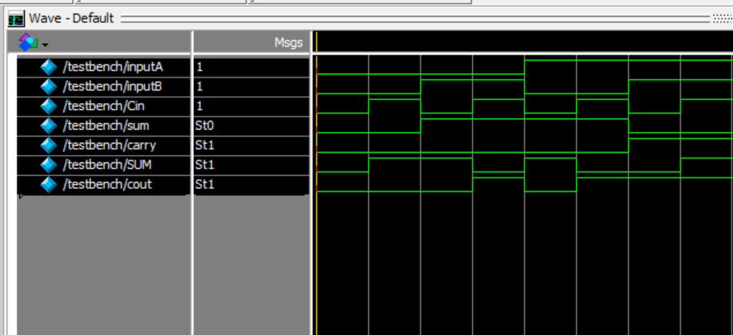
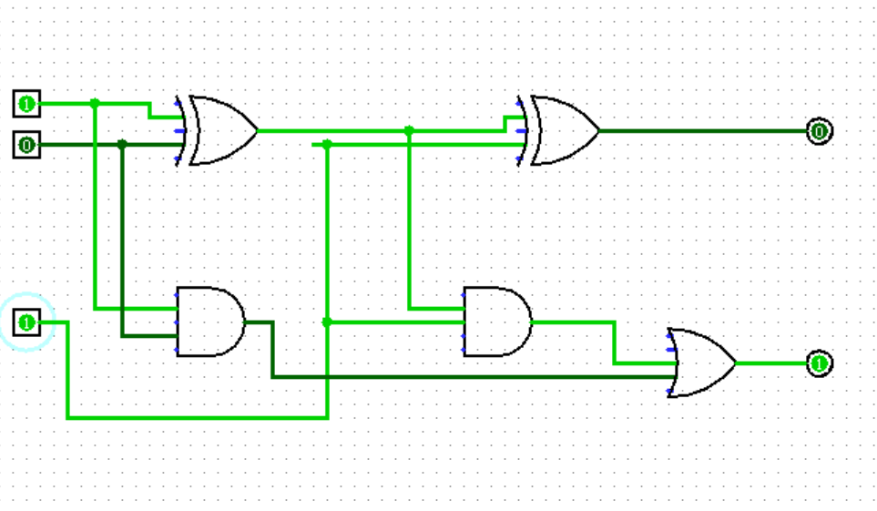

Task 2:

Description:
Here we Wrote Verilog code of 3x8 Decoder using Gate level and Dataflow level modeling simulated the results by writing testbench and made the circuit on logisim
Code:
module decoder3to8(Y,A,B,C);
input A,B,C;
output [7:0] Y;

wire nA,nB,nC;

not(nA,A);
not(nB,B);
not(nC,C);

and(Y[0],nA,nB,nC);
and(Y[1],nA,nB,C);
and(Y[2],nA,B,nC);
and(Y[3],nA,B,C);
and(Y[4],A,nB,nC);
and(Y[5],A,nB,C);
and(Y[6],A,B,nC);
and(Y[7],A,B,C);

endmodule

module testbench;

reg A,B,C;
wire [7:0] Y;

decoder3to8 D(Y,A,B,C);

initial
begin

A = 0;
B = 0;
C = 0;
#50;

A = 0;
B = 0;
C = 1;
#50;

A = 0;
B = 1;
C = 0;
#50;

A = 0;
B = 1;
C = 1;
#50;

A = 1;
B = 0;
C = 0;
#50;

A = 1;
B = 0;
C = 1;
#50;

A = 1;
B = 1;
C = 0;
#50;

A = 1;
B = 1;
C = 1;
#50;

end
endmodule
DATAFLOW
module decoder3to8(Y,A,B,C);

input A,B,C;
output [7:0] Y;

assign Y[0] = ~A & ~B & ~C;
assign Y[1] = ~A & ~B & C;
assign Y[2] = ~A & B & ~C;
assign Y[3] = ~A & B & C;
assign Y[4] = A & ~B & ~C;
assign Y[5] = A & ~B & C;
assign Y[6] = A & B & ~C;
assign Y[7] = A & B & C;

endmodule

module testbench;

reg A,B,C;
wire [7:0] Y;

decoder3to8 D(Y,A,B,C);

initial
begin

A = 0;
B = 0;
C = 0;
#50;

A = 0;
B = 0;
C = 1;
#50;

A = 0;
B = 1;
C = 0;
#50;

A = 0;
B = 1;
C = 1;
#50;

A = 1;
B = 0;
C = 0;
#50;

A = 1;
B = 0;
C = 1;
#50;

A = 1;
B = 1;
C = 0;
#50;

A = 1;
B = 1;
C = 1;
#50;

end

endmodule

Output:
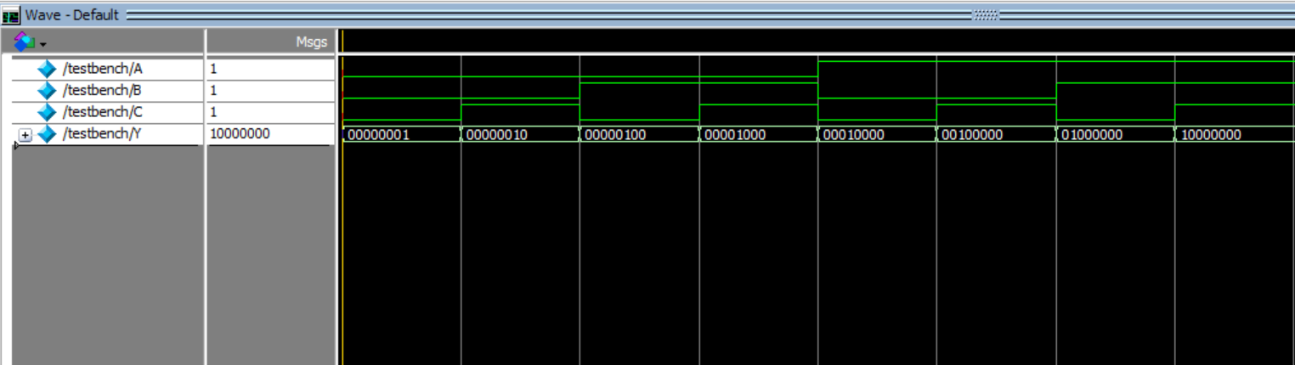
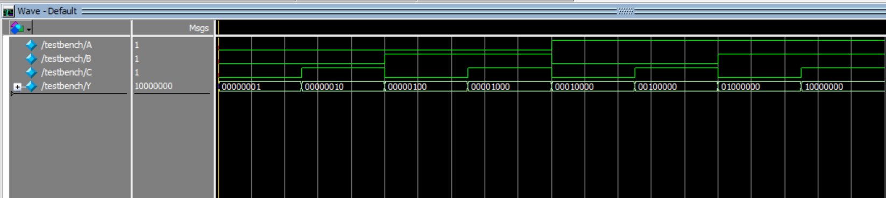
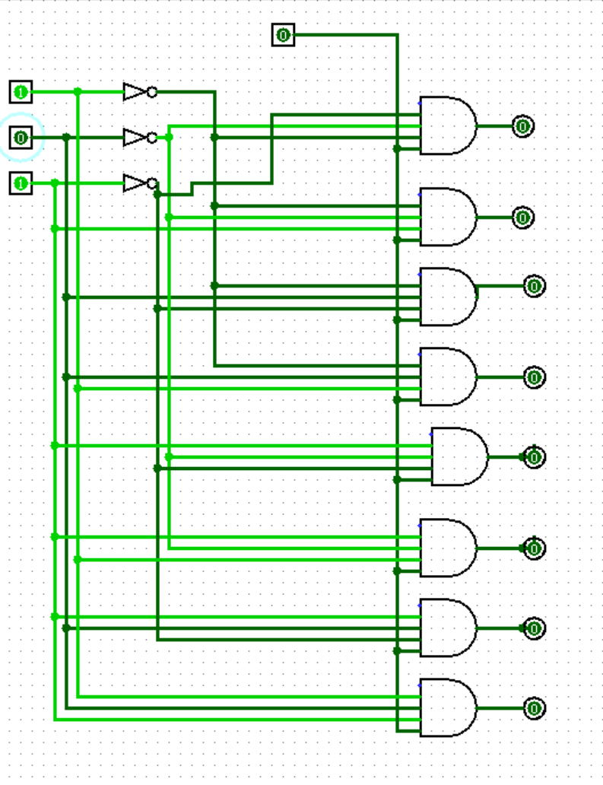

Task 3:

Description:
In this task we Wrote Verilog code of 8x1 multiplexer using Gate level and Dataflow modeling. Simulate the results by writing testbench and then made the circuit on logism
Code:
module mux8to1(Y,I,S);

input [7:0] I;
input [2:0] S;
output Y;

wire nS2,nS1,nS0;
wire w0,w1,w2,w3,w4,w5,w6,w7;

not(nS2,S[2]);
not(nS1,S[1]);
not(nS0,S[0]);

and(w0,I[0],nS2,nS1,nS0);
and(w1,I[1],nS2,nS1,S[0]);
and(w2,I[2],nS2,S[1],nS0);
and(w3,I[3],nS2,S[1],S[0]);
and(w4,I[4],S[2],nS1,nS0);
and(w5,I[5],S[2],nS1,S[0]);
and(w6,I[6],S[2],S[1],nS0);
and(w7,I[7],S[2],S[1],S[0]);

or(Y,w0,w1,w2,w3,w4,w5,w6,w7);

endmodule

module testbench;

reg [7:0] I;
reg [2:0] S;

wire Y;

mux8to1 MUX(Y,I,S);

initial
begin

I = 8'b10101010;

S = 3'b000;
#50;

S = 3'b001;
#50;

S = 3'b010;
#50;

S = 3'b011;
#50;

S = 3'b100;
#50;

S = 3'b101;
#50;

S = 3'b110;
#50;

S = 3'b111;
#50;

end

Endmodule
DATAFLOW
module mux8to1(Y,I,S);

input [7:0] I;
input [2:0] S;
output Y;

assign Y = (~S[2] & ~S[1] & ~S[0] & I[0]) |
(~S[2] & ~S[1] & S[0] & I[1]) |
(~S[2] & S[1] & ~S[0] & I[2]) |
(~S[2] & S[1] & S[0] & I[3]) |
(S[2] & ~S[1] & ~S[0] & I[4]) |
(S[2] & ~S[1] & S[0] & I[5]) |
(S[2] & S[1] & ~S[0] & I[6]) |
(S[2] & S[1] & S[0] & I[7]);

endmodule

module testbench;

reg [7:0] I;
reg [2:0] S;

wire Y;

mux8to1 MUX(Y,I,S);

initial
begin

I = 8'b10101010;

S = 3'b000;
#50;

S = 3'b001;
#50;

S = 3'b010;
#50;

S = 3'b011;
#50;

S = 3'b100;
#50;

S = 3'b101;
#50;

S = 3'b110;
#50;

S = 3'b111;
#50;

end

endmodule

Output:
